
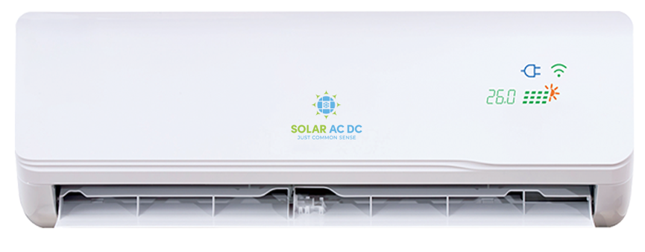

Below are the features that separate us from normal air conditioners and some operational tips on how to get the most from your Australian Designed Solar ACDC Hybrid Solar Air Conditioner.

Front Display
The front of your indoor unit will have a display that shows the temperature you have set when the unit is on. Besides the temperature display are a green panel, a plug image that can be white or blue and a WIFI image.

Green panel - This indicates the unit is using solar power.
Plug image - When white indicates AC (power grid) is available
- When blue indicates the unit is in AC Limiting mode – meaning:
  - When solar power is available the maximum the unit will draw from AC grid power is 100w to add to the DC
  - When no solar power is available (ie. Night) the units will draw the following maximums from the AC supply
  - 3.5kw 300w
  - 5.0kw 400w
  - 7.0kw 600w
WIFI image – This simply indicates that WIFI is available and connected

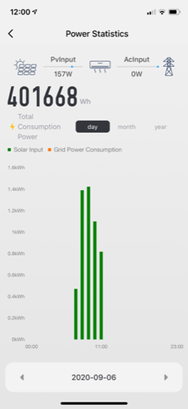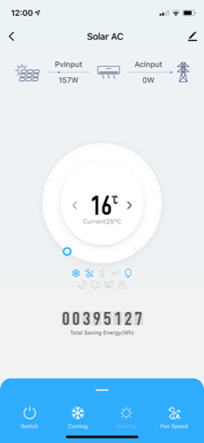

All functions are available via the WIFI app. There is full live visibility of current Solar power being consumed and AC power supply being consumed. A full history of both power consumptions will be available. Hourly, daily or weekly timers can be set.

Off Grid
If the grid power is disconnected the plug image will not come on and the green panel will be on or off. If they are on it means, there is enough power to run the outdoor compressor and it is cooling or heating the refrigerant and making cool or hot temperatures. If the green lights are not on, it means either the desired temperature has been reached and the compressor does not need to run or there is not enough power to run the compressor from the solar panels at that time.

If you have a limited power supply, we recommend using the AC Limiting mode for night use if required, to maximise the operational time available to avoid depleting your batteries.

If the unit is left on and the grid power is disconnected the unit will automatically turn itself on in the mornings when there is enough solar power and turn itself off at night when there is no longer enough solar power.

Fans
The indoor fan will run in cooling mode when there is enough power to run the fan, regardless of whether the compressor is working or not, this is to circulate the air. If the unit is on heating mode, the fan will also run however if the compressor is not on it will lift the louver fan to point up.

We hope you enjoy your new Solar ACDC Solar Air Conditioner, remember you are saving the planet and savings money at the same time.

Rob Miravet
Director
1300 GO ACDC
1300 46 2232


